

Additionel User – Informations, Counter SRB3206.1
( different to SRB3206 )

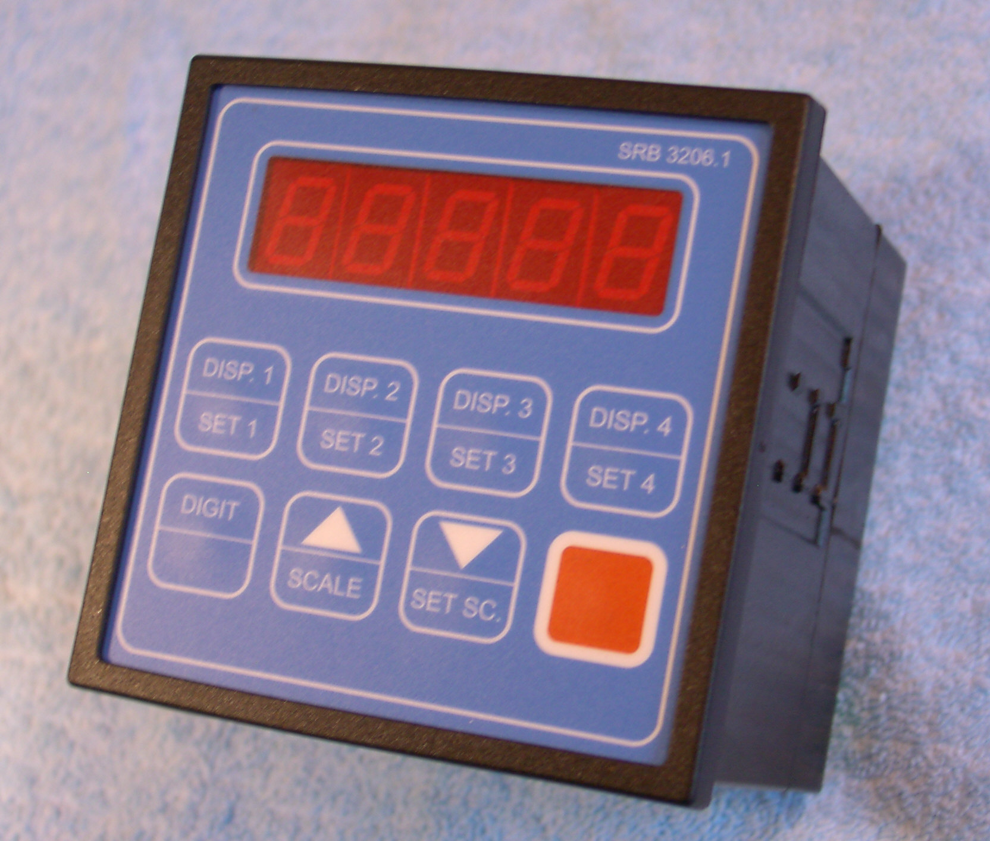

Reset counter 1 and 2

A switch with 16 positions is used to find the multi possibilities to reset the counter:

 |  | 0 | 1 | 2 | 3 | 4 | 5 | 6 | 7 | 8 | 9 | a | b | c | d | e | f
Counter 1 reset through | counter 1 |  | 1 |  | 3 |  | 5 |  |  |  | 9
Counter 1 reset through | counter 2 |  |  |  |  |  |  |  |  | 8 | 9 | a |  | c
Counter 1 reset through | ext. reset (13) |  | 1 | 2 |  | 4 | 5 | 6 |  | 8 | 9 | a |  | c
Counter 2 reset through | counter 1 |  | 2 | 3 |  |  |  | 6 |  |  |  | a
Counter 2 reset through | counter 2 |  |  |  |  | 4 | 5 | 6 |  |  |  |  |  | c
Counter 2 reset through | ext. reset (15) | 0 | 1 | 2 |  | 4 | 5 | 6 |  | 8 | 9 | a

Using only one channel:

Open the back-side. There is a connector with two possibilities: Pos. 2 – 3
( normal = 2 channels ), Pos 1 – 2: one channel – counting

1 – 2: left side ( near the switch)
2 – 3: right side ( away from the switch)

Attention: If you want to use power supply 24 V dc from SRB3102 for the counter, than it`s not allowed connecting mechanical contacts to the control unit (push-buttons, end- switches…) or you have to use a 470 ohm resistance in series to the contact!

