

SRB3206.1
Technical Data

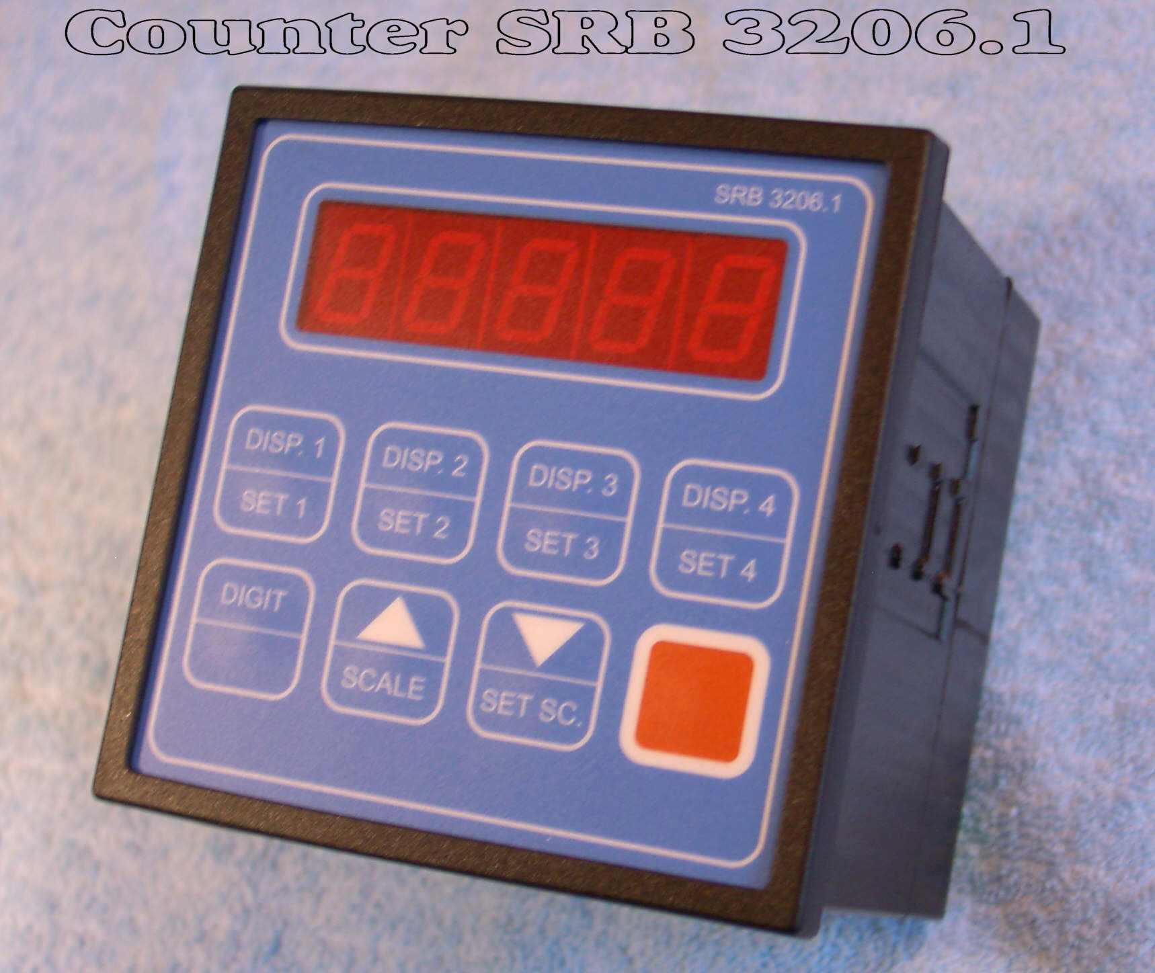

Digits 5

Range 0 - 999.99 or 0 - 99.999
Frequency 50 Hz
Reset input internal time < 2 μs
external response time < 2 μs,
minimum pulse width 80 μs
Enable input response time < 1 ms
Preset selection registration, range selection, up/down – selection,
enable selection, encoder input A and B:
logic 1 > 15,8 V
logic 0 > 2,0 V
Output npn, open collector, max. 40 mA / output,
pulse width 10 ms + / - 0,5 ms
Power supply 24 V, + / - 6 V, max. 3 W
Memory non – volative RAM, lithium – battery, 10 years
Operation temperature 0 … 50 degrees C
Storage temperature -20 … + 70 degrees C
IP rating IP54 by correct installation in an enclosure
CE EN DIN 61010-1, DIN EN 50081-2, DIN EN 50082-1

